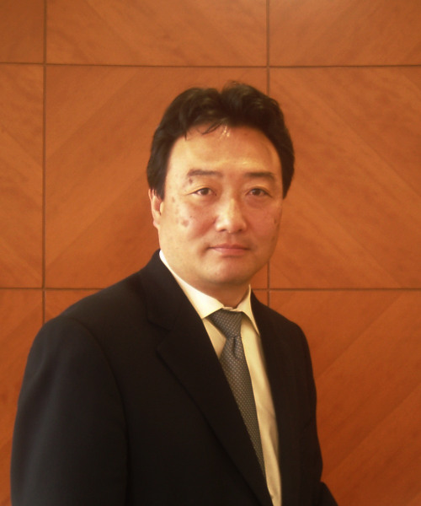
Masanaka Yokota
JMA Consultants Inc.
Vice President
Manager of Sales & Marketing Division
Certified Management Consultant
Member of MC Certification Committee in zen-noh-ren
Executive Board Member of Business Process Management Institute

Focused mainly on manufacturers, which are core competence of Japanese economy, Masanaka Yokota has been contributing to enhance the competitiveness of Japanese manufacturers since joined in JMA Consultants Inc. in 1985. He has a wide variety of multi-functional consulting expertise, such as QCD (Quality, Cost, and Delivery) innovation, supply chain restructuring, etc.

“Trends in Management Consulting in Japan”

Through the explanation of the management consulting service history in Japanese market, Masanaka Yokota will address the key contributions of the management consulting to Japanese economical growth since World War II.

- Key factors for Japanese companies to recover from the long downturn
- Roles of management consultants for the recovery
- Diversity of the management consulting services to approach critical issues to be faced by Japanese industry in the future

For Japanese Industry to Recover; MONODUKURI Survey 2003 (2004, JMAC)
Keys for Manufacturing Strategy (2004, NIKKEI BP)

