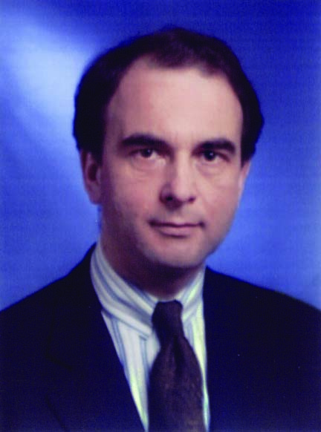

Dr. F. Arnulf Fleischer

Position
Director International Desk
Droege & Comp. GmbH
International Management consultants
Düsseldorf
Germany

Professional record and expertise
Studies at University of Duisburg with diploma and Ph. D in Economics.

25 years of consulting experience with broad experience in management and coordination of international and multidisciplinary projects:

1961 until 1993 with Kurt Salmon Associates the leading USA based consulting company with sector specialisation for the textile and clothing sector. In Europe responsible for strategy services and international management.

1994 until now with Droege & Comp. International Management Consultants. Top 10 German consulting company. Responsible for the coordination, controlling and support of Droege & Comp.'s international offices and cooperation partners related to its global marketing and project initiatives.

Abstract of presentation
An enlarging Europe: Chances for consultants of the old and new EU member states

Enlarging Europe provides growth perspectives for global and local companies. These market growth perspectives are correlated with the increase of the consulting industry.

To participate in the growth perspectives local and global companies have to implement market penetration and/or entry strategies. These companies need professional support with corresponding services and its implementation.

All this offers a multitude of project opportunities for global and local consultants,
e. g. based on the access to global companies on the one side and provision of local market know-how and network on the other.

