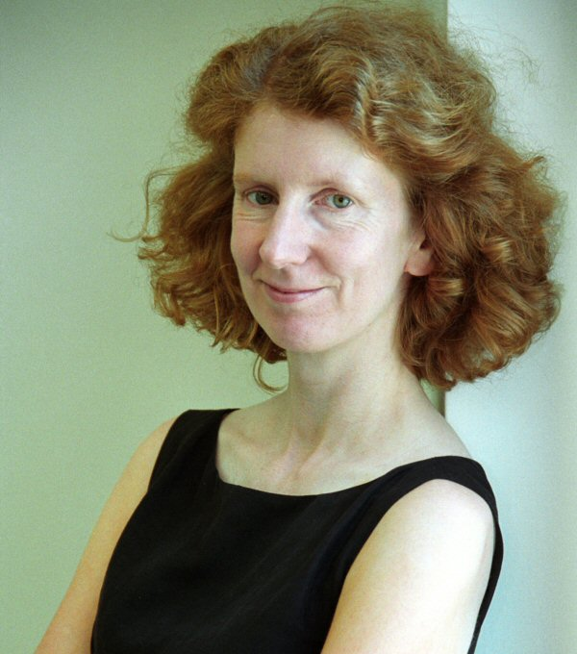

Fiona Czerniawska
Fiona is the founder of Arkimeda, a firm that specializes in researching and consulting on strategic issues in the consulting industry (www.arkimeda.com). She is also the Director of the UK Management Consultancies Association’s Think Tank.
Fiona has had more than 15 years experience as a management consultant, and now speaks, lectures and writes extensively on the consulting industry and related issues. Her most recent book is Business Consulting: A Guide to How it Works and How to Make it Work, published by The Economist.

Presentation – Ensuring sustainable value from consultants
The overwhelming majority of managers are partly or completely satisfied with the work their management consultants have done for them. However, satisfaction levels fall the further down the hierarchy of a project you go. Typically, managers claim that credibility, having a clear sense of purpose, good communication, and ensuring commitment and buy-in are critical in determining success. While such factors are all important, they are not enough. Getting the most from using consultants depends on setting up joint teams, taking a flexible approach and ensuring that the people who work side by side with the consultants gain personally from the experience.

