CONSTANTINUS, Europe’s Consulting and IT-Award goes international !
This year Feaco has joined the 2006 CONSTANTINUS Consulting and IT Awards, which has resulted in a new category: The International Constantinus Award. Enter now in the International Constatinus Award or participate in the Constantinus Gala on June 19, 2006. For more information visit: http://www.constantinus.net/

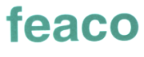
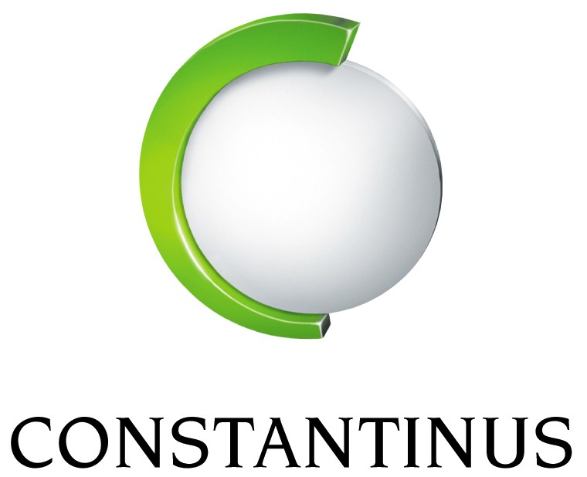
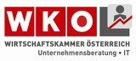

PROMOTE YOUR COMPANY AND THE INDUSTRY !
We want to learn about your outstanding international project to demonstrate the excellent performance of Europe’s consulting industry !
We want to learn about your outstanding international project because we know the effect good publicity can have on your company.
Let us be honest: How are customers to know that cooperation with Management Consultants brings successful solutions? The more outstanding practices are known, the better: Excellent solutions, increased growth – and less dumping: Quality wins !
QUALITY WINS !
Competition in every market is growing and becoming tougher – demonstrating quality becomes increasingly important. Therefore the Austrian Consultants – like colleagues in other countries, have started an offensive for quality in the industry by launching the CONSTANTINUS awards.
CONSTANTINUS has proven an excellent promotion tool in the past 3 years.
Therefore Feaco has decided to participate this year in the CONSTANTINUS 2006 process and open this high level platform to Management Consultants all over Europe. The Austrian Association is proud and honoured to support and organize for you the 2006 award.
Participation in CONSTANTINUS 2006 offers you the unique opportunity to have your project presented to a large audience, the European market and the international media. Your contribution will help shaping the image of our industry and demonstrate your strength, quality and success to customers.
We invite you: Submit your projects quickly for CONSTANTINUS 2006 – this is a Win-Win opportunity !
WIN-WIN FOR ME !
- CONSTANTINUS is a proven and successful concept developed by the Austrian Management Consultants – now available across Europe.
- The CONSTANTINUS awards get the attention of experts and the media. Image Turbo: Best practices help strengthening the Consulting Industry – More orders, better chances to win.
- More Business: Being selected as a nominee has proven an excellent reference for your company.
THE BEST, FOR ME, FOR THE INDUSTRY.
AUSTRIA’S NATIONAL AWARD GOES INTERNATIONAL:
- CONSTANTINUS 2006 is the fourth CONSTANTINUS event in Austria and the first Pan-European.
- The Austrian Federal Government has formally recognized CONSTANTINUS as a Federal Government Award in December 2005.
- Feaco has decided to open CONSTANTINUS with help of the Austrian Management Consultants to all its members.
- Apart from the original 5 national categories, 2006 will prominently feature the international category award.
THE JURY
Each category has its own jury. The international jury will be chaired by a former Minister of Foreign Affairs and contain national and international experts nominated by Feaco and the Austrian Federation.
SCOPE OF PROJECTS
Projects for the International CONSTANTINUS award should cover one or more of the following disciplines:
- Management Consulting
- Communication and Networks
- Information Technology (incl. Outsourcing)
- Personnel and Training
- Open Source Software
THE HIGHLIGHTS
- The CONSTANTINUS and CONSULTING GALA on June 19, 2006 in Graz/Austria Free for Winners, Nominees their customers and the media
- "WORLD CONSULTANTS DAY" is June 19 – worldwide press and media coverage
- CONSTANTINUS LOGO for your Homepage to alert the market to TROPHIES for the Winner and his customer
- You may submit up to two projects – simple on-line submission. Deadline: May 22, 2006
- Administration fee: € 250.-
- SIMPLE ONLINE PARTICIPATION: http://www.constantinus.net/

B r u s s e l s , M o n d a y 2 9 M a y 2 0 0 6
Conference venue: Hotel Renaissance, rue du Parnasse 19, B – 1050 Brussels
Conference language: English

10h00 Registration

10h30 Welcome and opening address:

Orlando Arango, Deputy Head of Division, Communication and Information Department, EIB
Eric Tourres, FEACO
Robert Couturier, EFCA

S E S S I O N I :

Chairman: Orlando Arango

Heinz Olbers, Head of Division, Lending Operations in Poland, EIB
Policy priorities – the medium-term perspective for long-term investment
Graham Cheshire, Senior loan officer, Division for lending operations in the Czech and Slovak Republic
Financial instruments for implementing EU policies – the EIB Group
René van Zonneveld, Head of Division, Energy projects, Projects Directorate
Project appraisal: methods and procedures

Q&A session

12h30 Lunch

14h00 S E S S I O N I I :

Emilio De La Guardia, Country Relationship Coordinator for EU South Region, EIB (JASPERS)
Marc Schublin, Head of “JEREMIE”, European Investment Fund
Special issues in financing: cases in regional development
René van Zonneveld, Head of Division, Energy projects, Projects Directorate
Special issues in project appraisal: making technical expertise available
N.N. EIB
The EIB approach to procurement

Q&A session
Concluding Remarks : EIB seminar in partnership with:
Robert Couturier, EFCA  Eric Tourres, FEACO  Orlando Arango, EIB  16h00 End of programme | 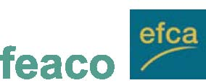
Updated programme and more information under www.eib.org/events
REGISTRATION FORM

B r u s s e l s, M o n d a y 2 9 M a y 2 0 0 6
Please fill in this form and return to: the FEACO Secretariat
+32 (0)2 209 0771 feaco@feaco.org +32 (0)2 250 0650

Registration is free of charge
Please type or use capital letters
Name: First name:
Position:
Company / Organisation:
Address:
Tel.: Fax:
E-mail:
 Will attend the conference
 Is unable to attend the conference
 Will be accompanied/represented by:
Name: |  | First name:
Position:
Company / Organisation:
Address:
Tel.: |  | Fax:
E-mail:

Date: Signature:

The 2006 Annual International Management Consultancy Conference:
New Trends and Tendencies in the Consulting Industry in an Enlarging Europe – Consulting the 21st Century”, Budapest, 8-10 November 2006

While other professions can trace their roots back several centuries, management consulting is less than a 100 years old; it is of younger vintage than either management practice or management theory. Management consulting has come to be recognized as a high-level practice. Annual global revenues in this sector have come to exceed $150 billion; clearly, management consulting has come of age. Although maturity has been achieved the consolidation process continues as a result of: Contradictory tendencies in major markets (developed markets, transitional economies, developing countries); New demands and new approaches, responses of the consulting industry to new demands; Increased competition and its effects on the market structure, strategies, behaviour, business ethics; Globalisation, international cooperation and, sometimes paradoxal, developments such as global market versus local knowledge, “generalism” versus specialisation, relationship based market and special expertise, concentration of markets, economies of scale and client focused, tailored services

The next annual conference of FEACO – 8-10 November, 2006 Budapest – will be an extraordinary forum to share ideas in relation to these contemporary issues with representatives of the management consulting profession from all over the world. Discussions around ten selected topics will create the opportunity to develop our profession to fit the new demands of the enlarging, changing Europe.

Budapest and the conference venue
The conference will be a major professional experience but these few days will offer you much more than this. Budapest is one of the most beautiful cities in the world with its historical places, the Danube and the surrounding hills, and the many new developments as a result of the changes in this part of Europe.

The social events of the conference will enable you to enlarge your network, build new relationships with your colleagues while enjoying spectacular places in Budapest and the famous Hungarian gastronomy. The pre- and post-conference programmes will offer you a great opportunity to discover Budapest and its surroundings.

To register or sponsor: http://www.feaco2006.hu/

The Conference will be combined with a FEACO International Networking Forum which will take place on 08 November in Budapest. Further information will be provided shortly.

